A
PROJECT REPORT ON
“EFFECTIVE PATTERN DISCOVERY FOR TEXT MINING”
Submitted in partial fulfilment of the requirement for the award of the degree of
BACHELOR OF TECHNOLOGY
IN
COMPUTER SCIENCE & ENGINEERING

By
M.N.M.PRADEEP 11K81A0583
M.SAIKRISHNA 11K81A0584
RAGHUNANDAN G 11K81A05A0
SANIA ALEX 11K81A05A2

UNDER THE GUIDANCE OF
Mr. A.Prakash
HOD, CSE Dept.


DEPARTMENT OF COMPUTER SCIENCE AND ENGINEERING
St. MARTIN’S ENGINEERING COLLEGE
(Affiliated to JNTU, Hyderabad)
DHULAPALLY (V), QUTBULLAPUR (M), SECUNDERABAD

2014-2015
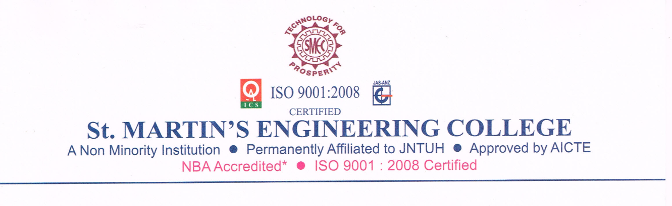
CERTIFICATE
This is to certify that the Project report titled “Effective Pattern Discovery for Text Mining” that is being submitted by M.N.M.Pradeep (11K81A0583), M.SaiKrishna (11K81A0584), Raghunandan G (11K81A05A0), Sania Alex (11K81A05A2), Students of B.Tech (CSE) fourth year at ST.MARTIN’S ENGINEERING COLLEGE, Dhulapally, Secunderabad, in partial fulfillment of the requirements for the award of the degree of Bachelor of Technology in Computer Science & Engineering is a record of bonafide work carried out by them.

The result of investigation enclosed in this report have been verified and found satisfactory.

Internal Guide Head of Department

Mr. A.PRAKASH Mr. A.PRAKASH

Department of CSE Department of CSE

External Examiner
ACKNOWLEDGEMENT

The satisfaction and euphoria that accompanies the successful completion of any task would be incomplete without the mention of the people who made it possible and whose encouragement and guidance have crowned our efforts with success.
We extend our deep sense of gratitude to Dr.C.VENKATARAMANA REDDY, PRINCIPAL, St. Martin’s Engineering College, Dhulapally for permitting us to undertake this project.
We are indebted to Mr. A.PRAKASH, HOD, Computer Science & engineering, St. Martin’s Engineering College, Dhulapally, for his support and guidance throughout our project.
We are thankful to Mr. ANAND THOTA, Assistant Professor, Computer Science & engineering, St. Martin’s Engineering College, Dhulapally for encouraging guidance and co-ordination throughout the project.
Finally, we express thanks to all those who have helped us in successfully completing this project. Furthermore we would like to thank our family and friends for their moral support and encouragement.
M.N.M.PRADEEP 11K81A0583
M.SAIKRISHNA 11K81A0584
RAGHUNANDAN G 11K81A05A0
SANIA ALEX 11K81A05A2

